Aaditee Agrawal
22BCS11305
FL_IoT 601 ‘A’
Ap lab assignment

- Set Matrix Zeroes

class Solution {
public:
void setZeroes(vector<vector<int>>& matrix) {
const int m = matrix.size();
const int n = matrix[0].size();
bool shouldFillFirstRow = false;
bool shouldFillFirstCol = false;

for (int j = 0; j < n; ++j)
if (matrix[0][j] == 0) {
shouldFillFirstRow = true;
break;
}

for (int i = 0; i < m; ++i)
if (matrix[i][0] == 0) {
shouldFillFirstCol = true;
break;
}
for (int i = 1; i < m; ++i)
for (int j = 1; j < n; ++j)
if (matrix[i][j] == 0) {
matrix[i][0] = 0;
matrix[0][j] = 0;
}
for (int i = 1; i < m; ++i)
for (int j = 1; j < n; ++j)
if (matrix[i][0] == 0 || matrix[0][j] == 0)
matrix[i][j] = 0;
if (shouldFillFirstRow)
for (int j = 0; j < n; ++j)
matrix[0][j] = 0;
if (shouldFillFirstCol)
for (int i = 0; i < m; ++i)
matrix[i][0] = 0;
}
};
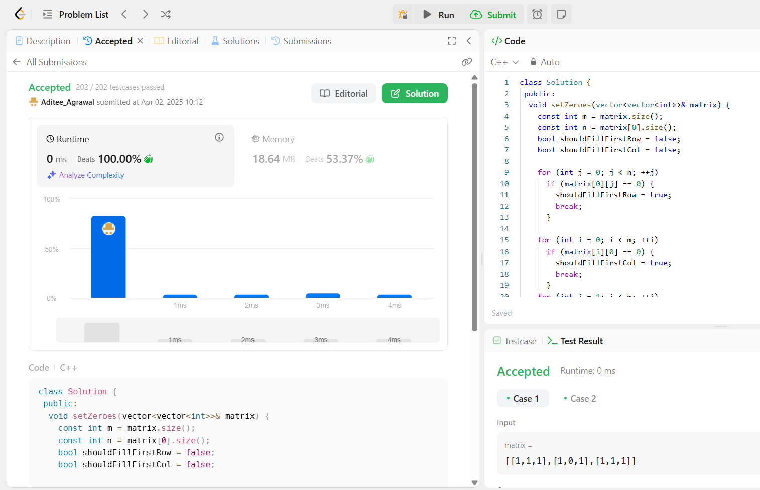

- Longest Substring Without Repeating Characters
class Solution {
public:
int lengthOfLongestSubstring(string s) {
int ans = 0;
vector<int> count(128);

for (int l = 0, r = 0; r < s.length(); ++r) {
++count[s[r]];
while (count[s[r]] > 1)
--count[s[l++]];
ans = max(ans, r - l + 1);
}

return ans;
}
};


- Reverse Linked List II
class Solution {
public:
ListNode* reverseBetween(ListNode* head, int left, int right) {
if (left == 1)
return reverseN(head, right);

head->next = reverseBetween(head->next, left - 1, right - 1);

return head;
}

private:
ListNode* reverseN(ListNode* head, int n) {
if (n == 1)
return head;

ListNode* newHead = reverseN(head->next, n - 1);
ListNode* headNext = head->next;
head->next = headNext->next;
headNext->next = head;

return newHead;
}
};
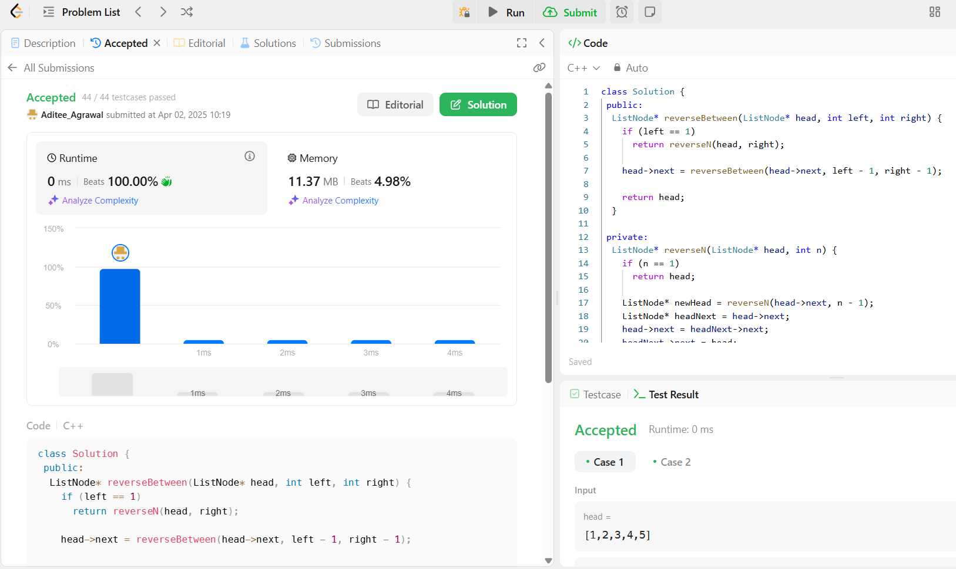

- Linked List Cycle
class Solution {
public:
bool hasCycle(ListNode* head) {
ListNode* slow = head;
ListNode* fast = head;

while (fast != nullptr && fast->next != nullptr) {
slow = slow->next;
fast = fast->next->next;
if (slow == fast)
return true;
}

return false;
}
};
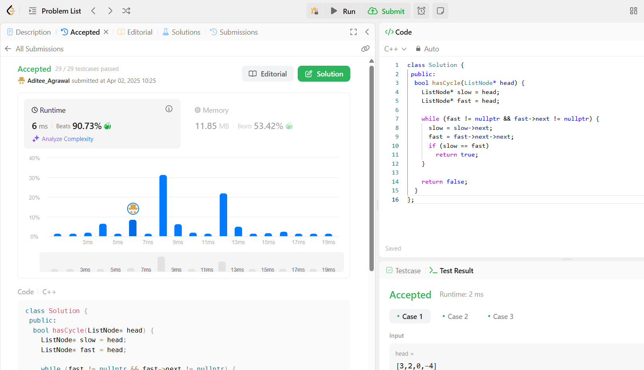

- The Skyline Problem

class Solution {
public:
vector<vector<int>> getSkyline(const vector<vector<int>>& buildings) {
const int n = buildings.size();
if (n == 0)
return {};
if (n == 1) {
const int left = buildings[0][0];
const int right = buildings[0][1];
const int height = buildings[0][2];
return {{left, height}, {right, 0}};
}

const vector<vector<int>> left =
getSkyline({buildings.begin(), buildings.begin() + n / 2});
const vector<vector<int>> right =
getSkyline({buildings.begin() + n / 2, buildings.end()});
return merge(left, right);
}

private:
vector<vector<int>> merge(const vector<vector<int>>& left,
const vector<vector<int>>& right) {
vector<vector<int>> ans;
int i = 0;
int j = 0;
int leftY = 0;
int rightY = 0;

while (i < left.size() && j < right.size())
if (left[i][0] < right[j][0]) {
leftY = left[i][1];
addPoint(ans, left[i][0], max(left[i++][1], rightY));
} else {
rightY = right[j][1];
addPoint(ans, right[j][0], max(right[j++][1], leftY));
}

while (i < left.size())
addPoint(ans, left[i][0], left[i++][1]);

while (j < right.size())
addPoint(ans, right[j][0], right[j++][1]);

return ans;
}

void addPoint(vector<vector<int>>& ans, int x, int y) {
if (!ans.empty() && ans.back()[0] == x) {
ans.back()[1] = y;
return;
}
if (!ans.empty() && ans.back()[1] == y)
return;
ans.push_back({x, y});
}
};


- Longest Increasing Subsequence II
struct SegmentTreeNode {
int lo;
int hi;
int maxLength;
std::unique_ptr<SegmentTreeNode> left;
std::unique_ptr<SegmentTreeNode> right;
SegmentTreeNode(int lo, int hi, int maxLength,
std::unique_ptr<SegmentTreeNode> left = nullptr,
std::unique_ptr<SegmentTreeNode> right = nullptr)
: lo(lo),
hi(hi),
maxLength(maxLength),
left(std::move(left)),
right(std::move(right)) {}
};

class SegmentTree {
public:
explicit SegmentTree() : root(make_unique<SegmentTreeNode>(0, 1e5 + 1, 0)) {}

void updateRange(int i, int j, int maxLength) {
update(root, i, j, maxLength);
}
int queryRange(int i, int j) {
return query(root, i, j);
}

private:
std::unique_ptr<SegmentTreeNode> root;

void update(std::unique_ptr<SegmentTreeNode>& root, int i, int j,
int maxLength) {
if (root->lo == i && root->hi == j) {
root->maxLength = maxLength;
root->left = nullptr;
root->right = nullptr;
return;
}
const int mid = root->lo + (root->hi - root->lo) / 2;
if (root->left == nullptr) {
root->left = make_unique<SegmentTreeNode>(root->lo, mid, root->maxLength);
root->right =
make_unique<SegmentTreeNode>(mid + 1, root->hi, root->maxLength);
}
if (j <= mid)
update(root->left, i, j, maxLength);
else if (i > mid)
update(root->right, i, j, maxLength);
else {
update(root->left, i, mid, maxLength);
update(root->right, mid + 1, j, maxLength);
}
root->maxLength = merge(root->left->maxLength, root->right->maxLength);
}

int query(std::unique_ptr<SegmentTreeNode>& root, int i, int j) {
if (root->left == nullptr)
return root->maxLength;
if (root->lo == i && root->hi == j)
return root->maxLength;
const int mid = root->lo + (root->hi - root->lo) / 2;
if (j <= mid)
return query(root->left, i, j);
if (i > mid)
return query(root->right, i, j);
return merge(query(root->left, i, mid), query(root->right, mid + 1, j));
}

int merge(int left, int right) const {
return max(left, right);
};
};

class Solution {
public:
int lengthOfLIS(vector<int>& nums, int k) {
int ans = 1;
SegmentTree tree;

for (const int num : nums) {
const int left = max(1, num - k);
const int right = num - 1;
const int maxLength = tree.queryRange(left, right) + 1;
ans = max(ans, maxLength);
tree.updateRange(num, num, maxLength);
}

return ans;
}
};
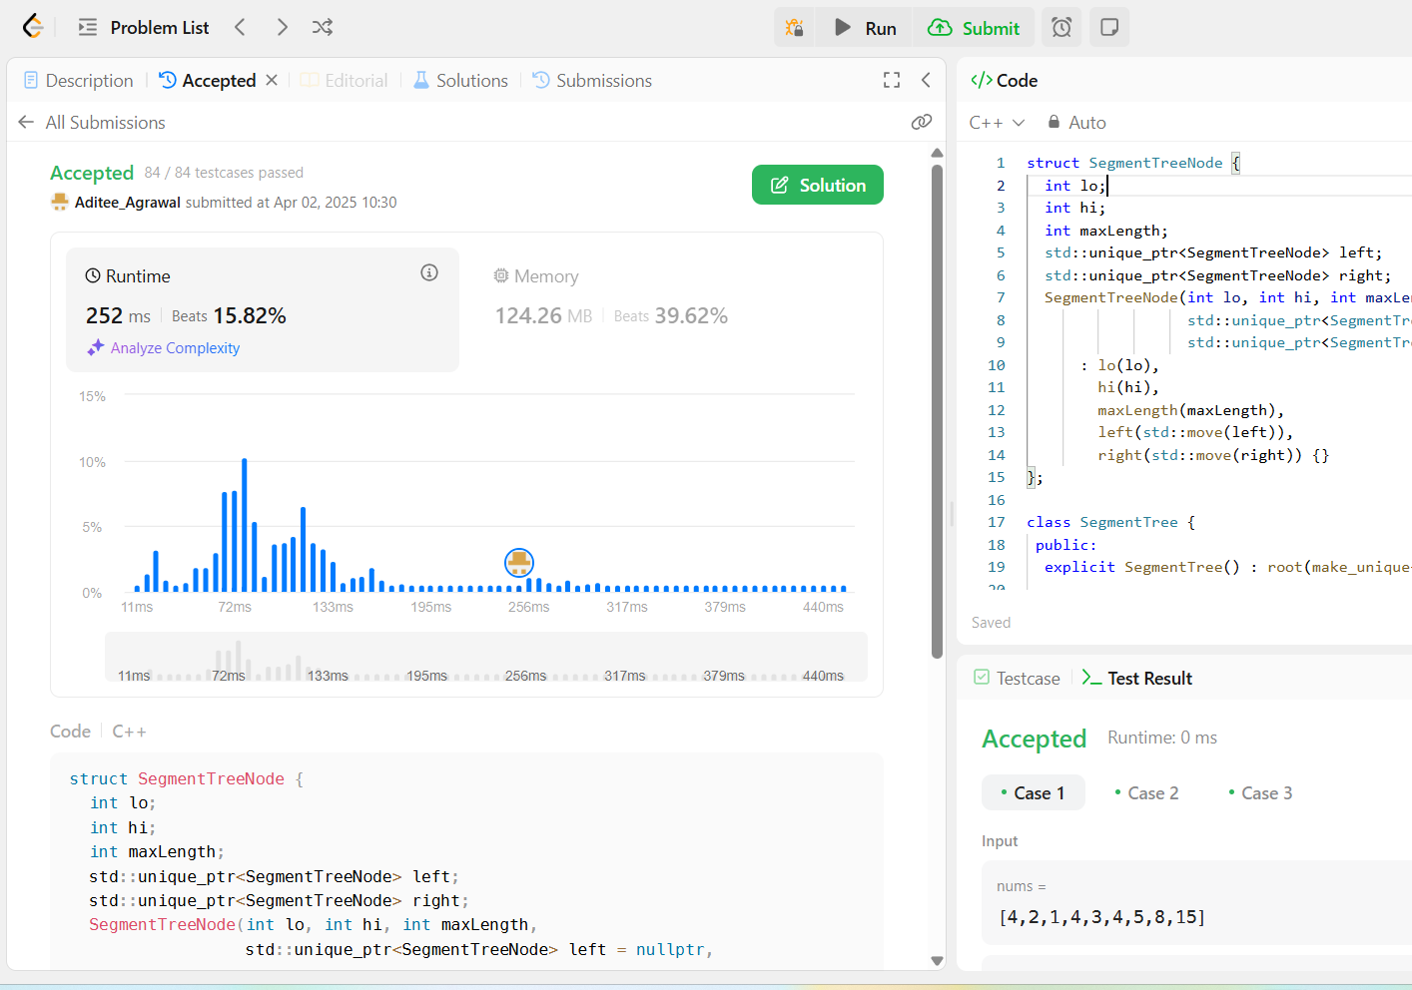

- Search a 2D Matrix II
class Solution {
public:
bool searchMatrix(vector<vector<int>>& matrix, int target) {
int r = 0;
int c = matrix[0].size() - 1;

while (r < matrix.size() && c >= 0) {
if (matrix[r][c] == target)
return true;
if (matrix[r][c] > target)
--c;
else
++r;
}

return false;
}
};
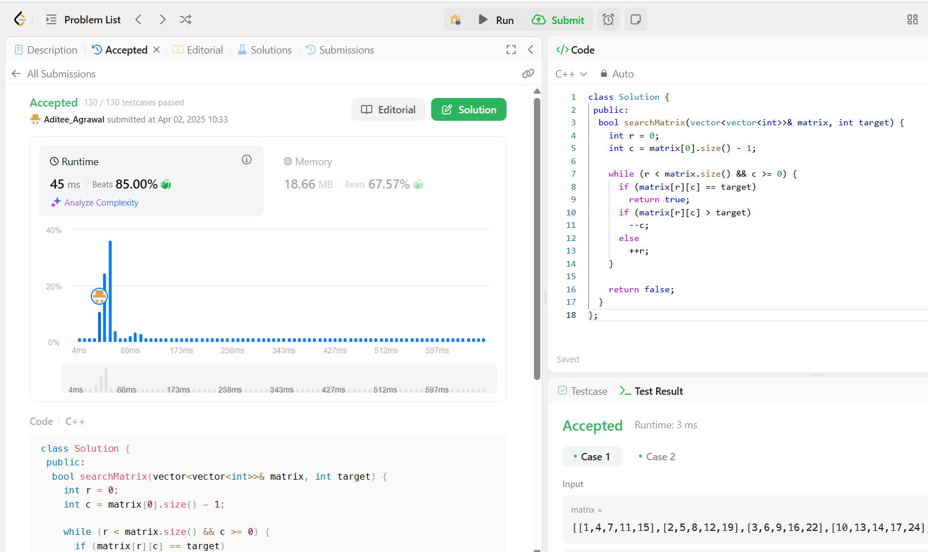

- Word Break
class Solution {
public:
bool wordBreak(string s, vector<string>& wordDict) {
return wordBreak(s, {wordDict.begin(), wordDict.end()}, {});
}
private:
bool wordBreak(const string& s, const unordered_set<string>&& wordSet,
unordered_map<string, bool>&& mem) {
if (wordSet.contains(s))
return true;
if (const auto it = mem.find(s); it != mem.cend())
return it->second;
for (int i = 1; i < s.length(); ++i) {
const string& prefix = s.substr(0, i);
const string& suffix = s.substr(i);
if (wordSet.contains(prefix) &&
wordBreak(suffix, std::move(wordSet), std::move(mem)))
return mem[s] = true;
}

return mem[s] = false;
}
};


- Longest Increasing Path in a Matrix

class Solution {
public:
int longestIncreasingPath(vector<vector<int>>& matrix) {
const int m = matrix.size();
const int n = matrix[0].size();
int ans = 0;
vector<vector<int>> mem(m, vector<int>(n));

for (int i = 0; i < m; ++i)
for (int j = 0; j < n; ++j)
ans = max(ans, dfs(matrix, i, j, INT_MIN, mem));
return ans;
}
private:
int dfs(const vector<vector<int>>& matrix, int i, int j, int prev,
vector<vector<int>>& mem) {
if (i < 0 || i == matrix.size() || j < 0 || j == matrix[0].size())
return 0;
if (matrix[i][j] <= prev)
return 0;
int& ans = mem[i][j];
if (ans > 0)
return ans;

const int curr = matrix[i][j];
return ans = 1 + max({dfs(matrix, i + 1, j, curr, mem),
dfs(matrix, i - 1, j, curr, mem),
dfs(matrix, i, j + 1, curr, mem),
dfs(matrix, i, j - 1, curr, mem)});
}
};
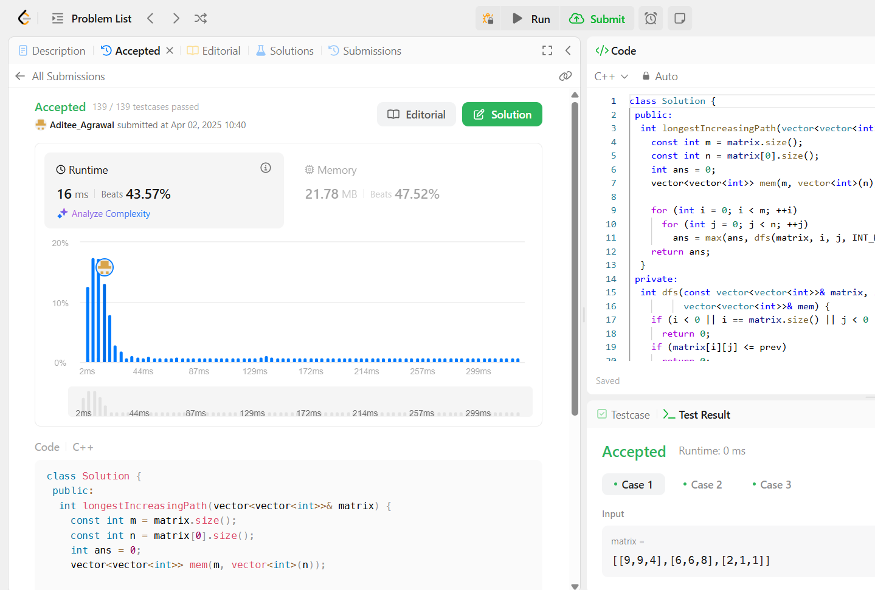

- Trapping Rain Water

class Solution {
public:
int trap(vector<int>& height) {
const int n = height.size();
int ans = 0;
vector<int> l(n);
vector<int> r(n);

for (int i = 0; i < n; ++i)
l[i] = i == 0 ? height[i] : max(height[i], l[i - 1]);

for (int i = n - 1; i >= 0; --i)
r[i] = i == n - 1 ? height[i] : max(height[i], r[i + 1]);

for (int i = 0; i < n; ++i)
ans += min(l[i], r[i]) - height[i];

return ans;
}
};
